**Name:** Basant Raj Kadel  
**ID:** 80117739

**Lab 6: Solving Reachability Issues with Inter-VLAN Routing**

**1. Objective**

To diagnose and resolve the connectivity problem between two VLANs (VLAN 19 for Account and VLAN 28 for Lab) by implementing Inter-VLAN routing, enabling a PC in the Account department to communicate with a PC in the Computer Lab.

**2. Theory**

The problem described is a classic symptom of Layer 2 network segmentation using VLANs. A VLAN (Virtual Local Area Network) creates separate broadcast domains. While this improves security and network performance by isolating traffic, it also means that devices in different VLANs cannot communicate with each other by default.

* **Layer 2 Switches:** Operate based on MAC addresses and VLAN tags. They are excellent for forwarding traffic *within* the same VLAN but have no intelligence to route packets *between* different VLANs.
* **The Solution:** Inter-VLAN Routing. To allow communication between VLANs, a Layer 3 device is required. This device (a router or a Layer 3 switch) makes decisions based on IP addresses and can forward packets between different networks (VLANs).
* **Router-on-a-Stick:** This is a common method for Inter-VLAN routing. It uses a single physical router interface configured with multiple sub-interfaces. Each sub-interface is assigned to a specific VLAN and is given the IP address that will serve as the default gateway for all devices in that VLAN.

In this lab, the router will be the gateway for both networks, allowing it to receive packets from one VLAN and route them to the other.

**3. Diagram, Procedures, and Commands**

My Roll Number is 39. Therefore, the networks are:

* VLAN 19 (Account): 192.168.39.0/29
  + Usable IP Range: 192.168.39.1 to 192.168.39.6
  + Subnet Mask: 255.255.255.248
* VLAN 28 (Lab): 192.168.39.8/29
  + Usable IP Range: 192.168.39.9 to 192.168.39.14
  + Subnet Mask: 255.255.255.248

**Network Diagram**

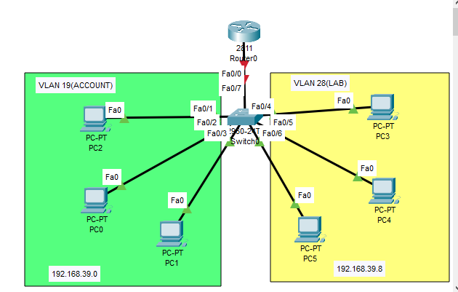

**Configuring the Switch (VLANs and Trunk)**The switch must be configured to recognize the VLANs and to pass their traffic to the router via a trunk link.

1. Click on the switch and go to the CLI.
2. Enter the following commands:

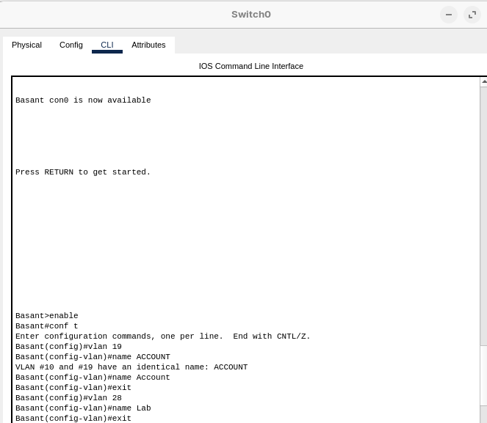

! Assign access ports to the respective VLANs   
VLAN 19:

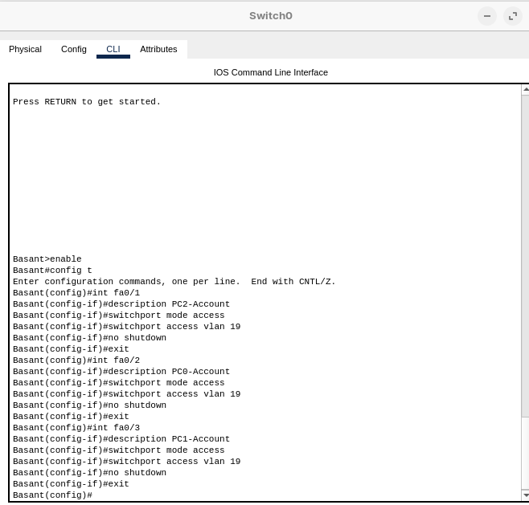

VLAN 28:  
 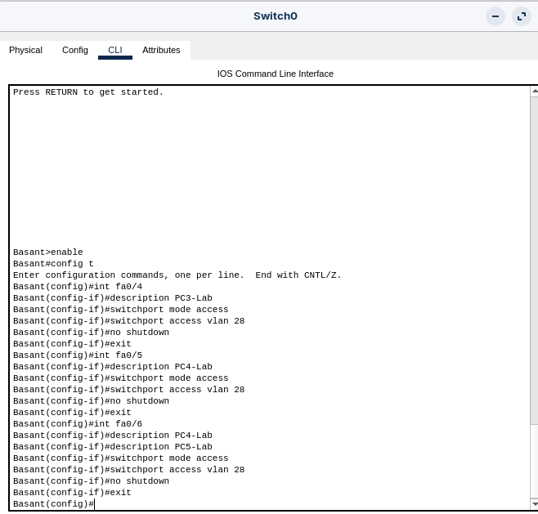

Configure the port connected to the router as a TRUNK

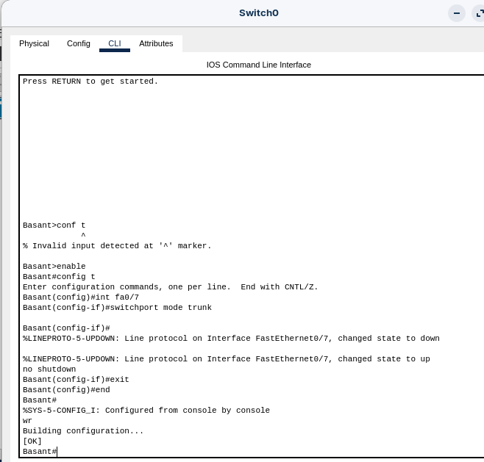

**Configuring the Router (Router-on-a-Stick)**The router will be configured with sub-interfaces to route between the VLANs.

1. Click on the router and go to the CLI.
2. Enter the following commands:

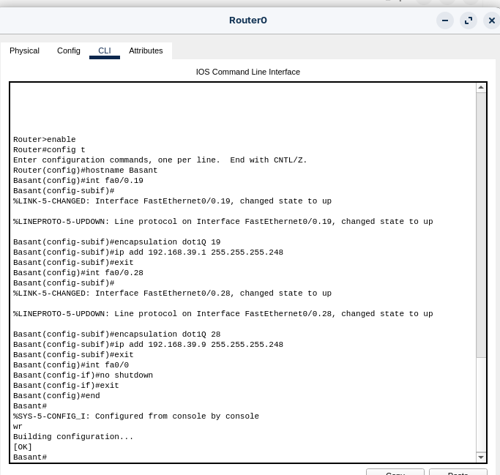

**Step 3: Configure the PCs**  
Each PC must be configured with an IP address within its VLAN's range and the router's corresponding sub-interface as its default gateway.

* PCs in VLAN 19 (Account):
  + IP Address: 192.168.39.2,3,4
  + Subnet Mask: 255.255.255.248
  + Default Gateway: 192.168.39.1
* PCs in VLAN 28 (Lab):
  + IP Address: 192.168.39.10,11,12
  + Subnet Mask: 255.255.255.248
  + Default Gateway: 192.168.39.9

**4. Testing and Verification**

1. Initial Test (Before Router Config):
   * From the PC in VLAN 19 (192.168.39.2), ping the PC in VLAN 28 (192.168.39.10).  
      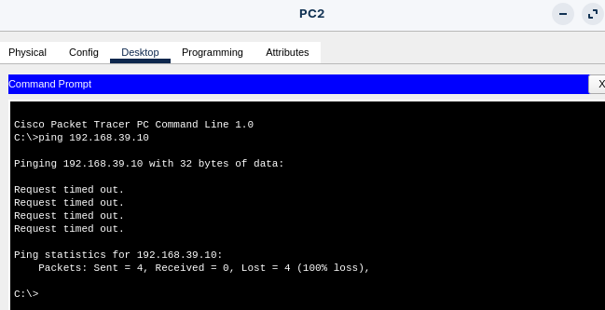
   * Result: FAILURE. This confirms the initial problem described in the lab.
2. Final Test (After Router Config):
   * From the PC in VLAN 19 (192.168.39.2), ping the PC in VLAN 28 (192.168.39.10) again.  
      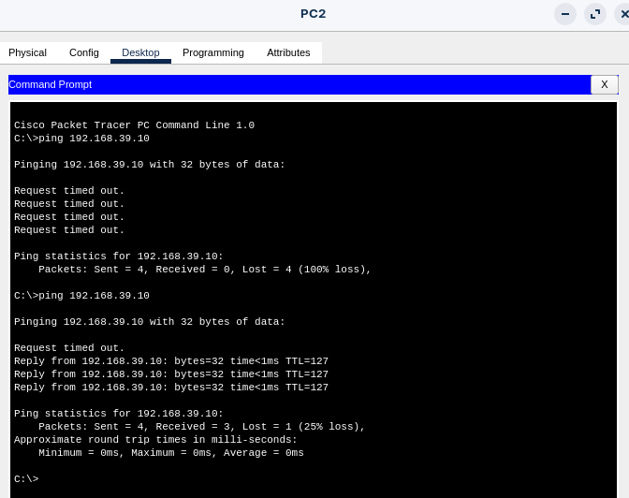
   * Result: SUCCESS. This verifies that Inter-VLAN routing is now functioning correctly.

Verification Command on Router: 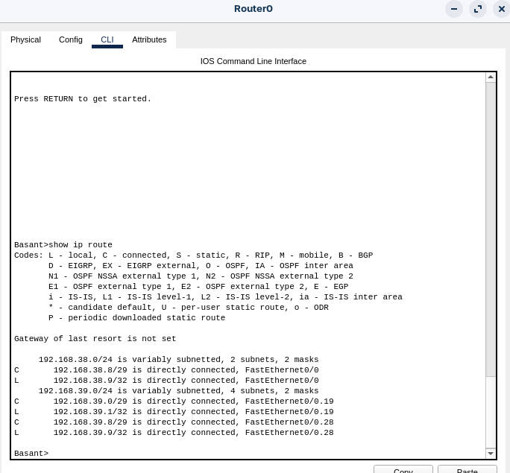

*This command will show the routing table, which should list both networks (192.168.39.0/29 and 192.168.39.8/29) as directly connected, proving the router knows how to reach each VLAN.*

**5. Conclusion**

The lab successfully demonstrated the cause and solution for connectivity issues between VLANs. The initial ping failure confirmed that Layer 2 switches cannot forward traffic between VLANs. The implementation of the Router-on-a-Stick model for Inter-VLAN routing provided the necessary Layer 3 functionality. After configuring the router with VLAN sub-interfaces and setting the appropriate gateways on the PCs, communication between the Account and Lab VLANs was restored. This proves that a router is essential for controlled communication between logically separated network segments (VLANs).